INTRODUCTION TO LINUX

ASSIGNMENT

1. 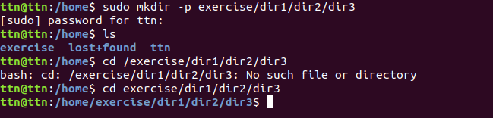

2. 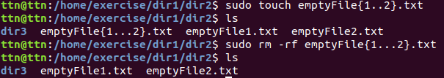

3. 

4. 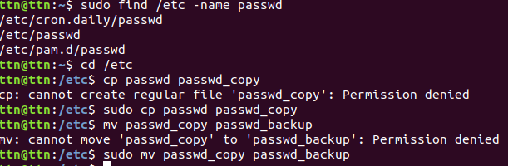

5.

Less:

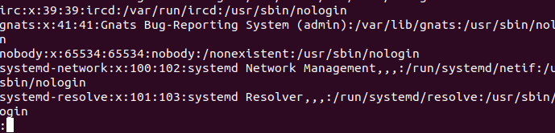

More:

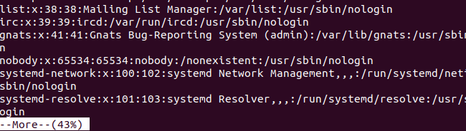

Cat :

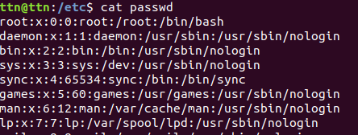

Stings:

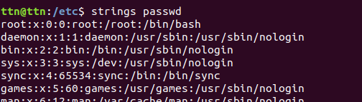

6.

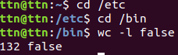

7.

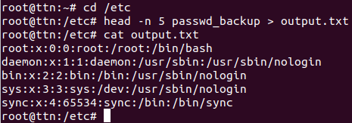

8.

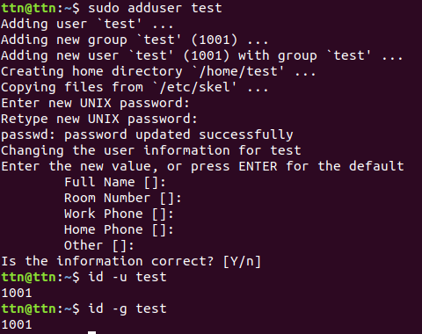

9.

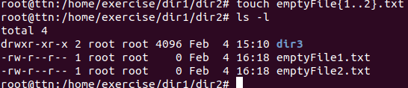

10.

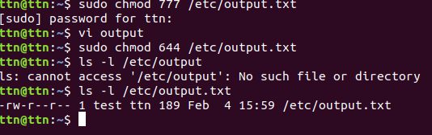

11.



12.

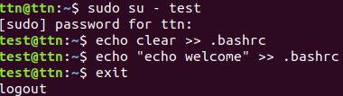

13.

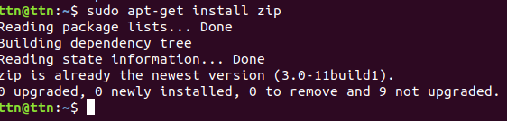

14.

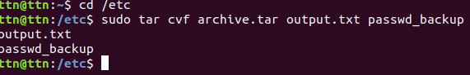

15.

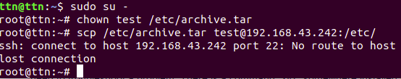

16.

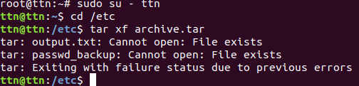

17.

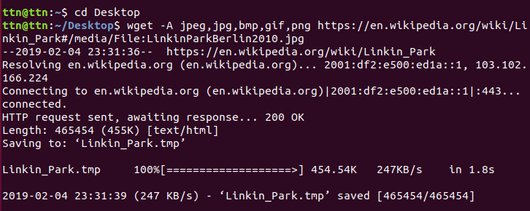

18.

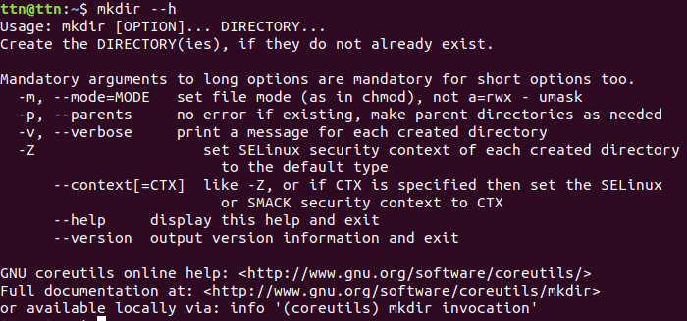

19.



20. With the help of “whereis” command in Linux, we can do that.

whereis xyz